**SNF(0L3) SCALED**

a = 0.5*(1-p-kap + sqrt((1-p-kap)^2+4*kap))

dm/dt = alf*a - m

dptot/dt = m - p

dp/dt = ptot - 2*p

aux q=ptot-p

par alf=40, kap=0.002

@ Yplot=m, Ylo=0, Yhi=1

done

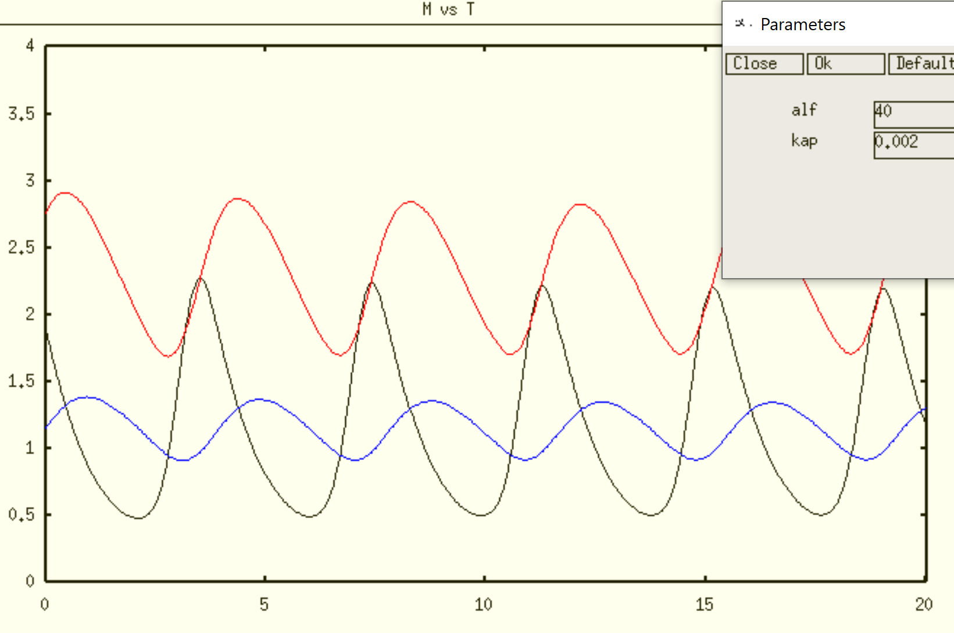

Black = mRNA, Blue = Pnuc, Red = Ptot

|  |  |
| --- | --- |
|  |  |

For Kd/AT = 0.002, HB @ alf = 9.8 and 66.9; max val Ptot ≈ 2.5 - 3 over most of the oscill range

Alf = 30 seems to be a good choice for ‘basal’ value (homozygous diploid). Heterozygous diploid (alf = 15) still oscillates, and tetraploid (alf = 60) still oscillates.

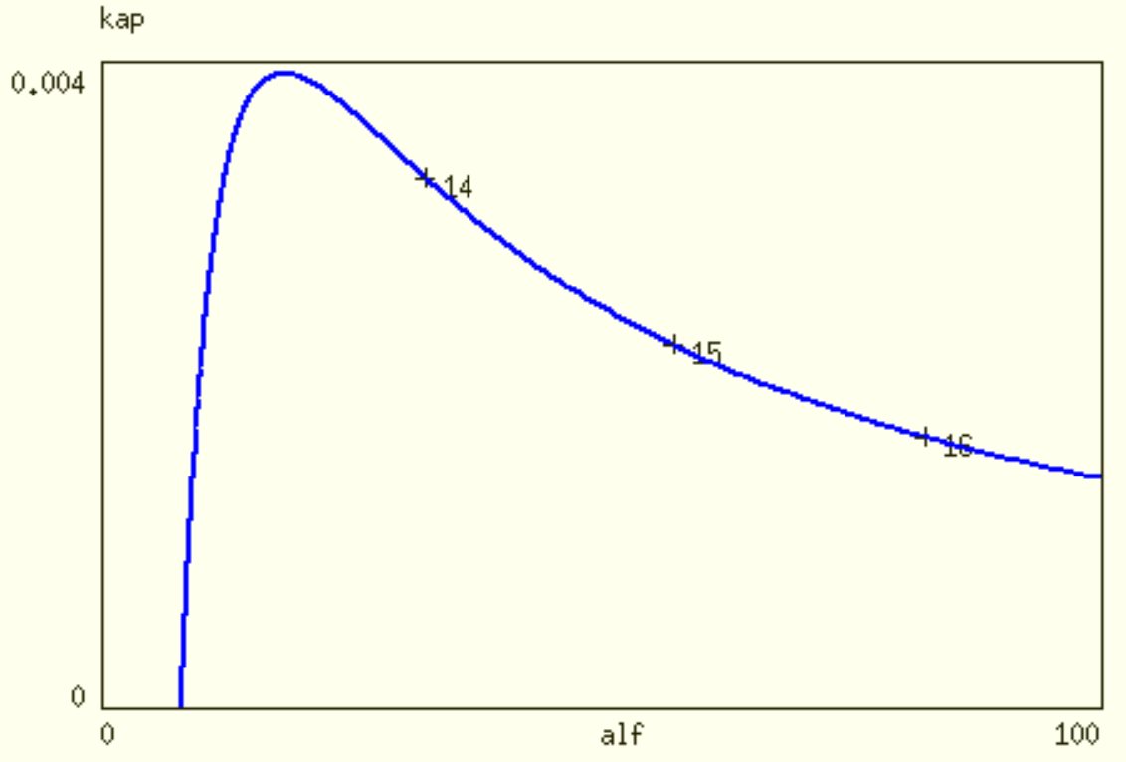

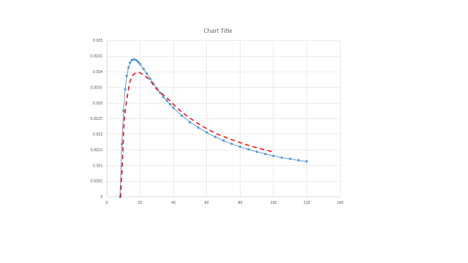

Red curve = Auto bif’n curve. Blue curve is my approximation:

|  |  |
| --- | --- |
| Jim Keener derived an exact form for bifn curve:    *K = K*d*/A*T*, a = 1/A*T |  |

**# SNF(0L3) model SCALED-FC**

a = 0.5*(1-p-kap + sqrt((1-p-kap)^2+4*kap))

alf = FCRTR*alf0/FCATR

kap = kap0/FCATR

dm/dt = alf*a - m

dptot/dt = m - p

dp/dt = ptot - 2*p

aux q=ptot-p

par FCRTR=.0333, FCATR=1

par alf0=30, kap0=0.002

@ Yplot=m, Ylo=0, Yhi=1

Done

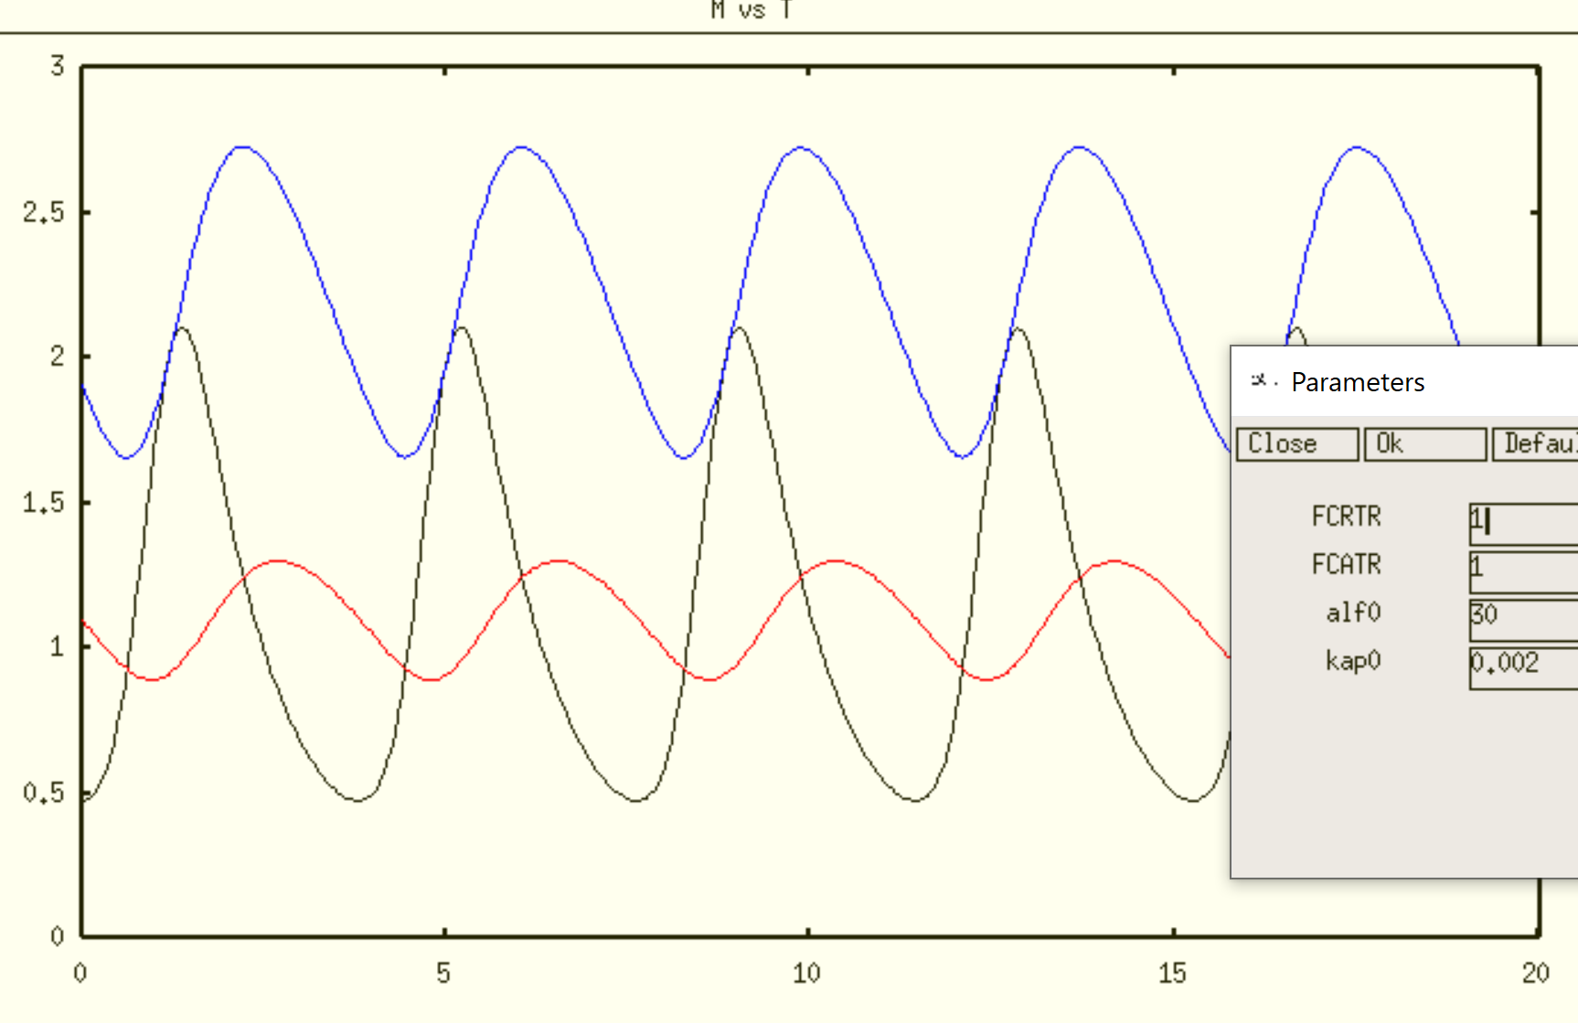

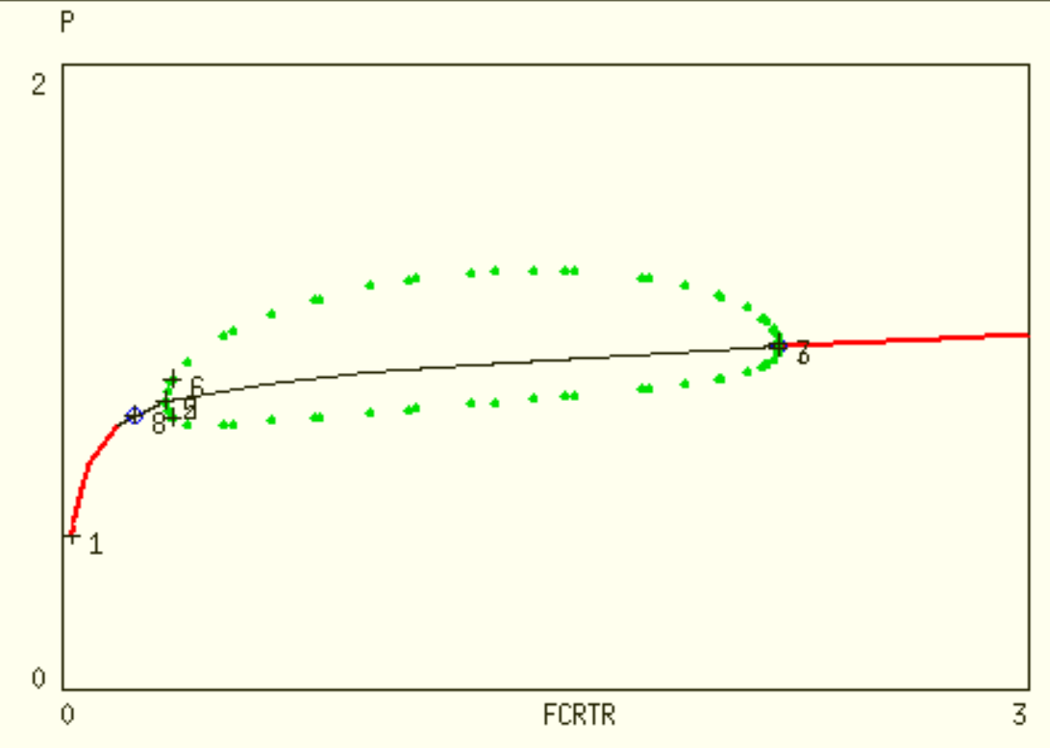

For FCATR = 1, HB @ FCRTR = 0.3265, 2.231 (alf = 9.8, 66.9)

|  |  |
| --- | --- |
|  |  |

With default AUTO parameters (MX at endpoints 9, 14) Jim Keener’s analytical formula

There is some mistake in this calculation!!!

Let’s get one-par bifn diagram at FCATR = 2 and 4

|  |  |
| --- | --- |
|  |  |
| FCATR = 2; HB @ 0.5832, 9.975 | FCATR = 4; HB @ 1.113, 41.77 |

Notice that, for FCATR = 2 or 4 and FCRTR = 5 or larger, PERnuc(t) dips slightly below 1 and is considerably larger than 1 for much of the cycle. Hence, PER mRNA is synthesized in a short burst and then decays slowly for the rest of the cycle. For example:

|  |  |
| --- | --- |
|  |  |
| FCATR = 2; FCRTR = 5 | FCATR = 4; FCRTR = 10 |

mRNA (black); PERnuc (red); PERtot (blue)

Notice that mRNA(t) is NOT sinusoidal, so these simulations (for large FCRTR) are NOT suitable for modeling CR in mammalian cells (Luciferase reporter strains, driven by E-box show very symmetric, sinusoidal fluorescence).

When we explore the ‘oscillatory region’ on two-par bif’n diagrams, we should make two tests for ‘circadian oscillations’:

1. Period close to 24 h
2. M(t) close to ‘sinusoidal’

There are two ways to do test #2. (i) Easy way: Calculate the ratio (Δt for phase of increasing M(t)) / (Δt for phase of decreasing M(t)) ; this ratio should be close to 1 (say, 0.9 – 1.1). (ii) Elegant way: Calculate the first three coefficients (c0, c1, c2) of Fourier series approximation to M(t); c0 is offset, c1 is contribution of sin(2pi*t/T), c2 is contribution of sin(4pi*t/T); c2 should be much smaller than c1.

**# NNF(0L3) model SCALED**

alf = FCRTR*alf0/FCATR

kap = kap0*rho/FCATR

#E-box Rate Law 0

RL0 = 0.5*(1-(P/AT)-(kap/AT)+sqrt((1-(P/AT)-(kap/AT))^2+4*kap/AT))

dm/dt = alf*RL0 - m

dptot/dt = m - p

dp/dt = ptot - 2*p

dAT/dt = del*(FCATR*Amax/(Kv+V) - AT)

dV/dt = del*(Vmax*RL0 - V)

aux q=ptot-p

par FCRTR=1, FCATR=1

par alf0=30, kap0=0.002, rho=1

par del=0.2, Amax=2.8, Vmax=5, Kv=.1

@ Yplot=m, Ylo=0, Yhi=4

done

First, reproduce SNF(0L3) with V(t)=0 (green) and AT(t)=1 (orange)

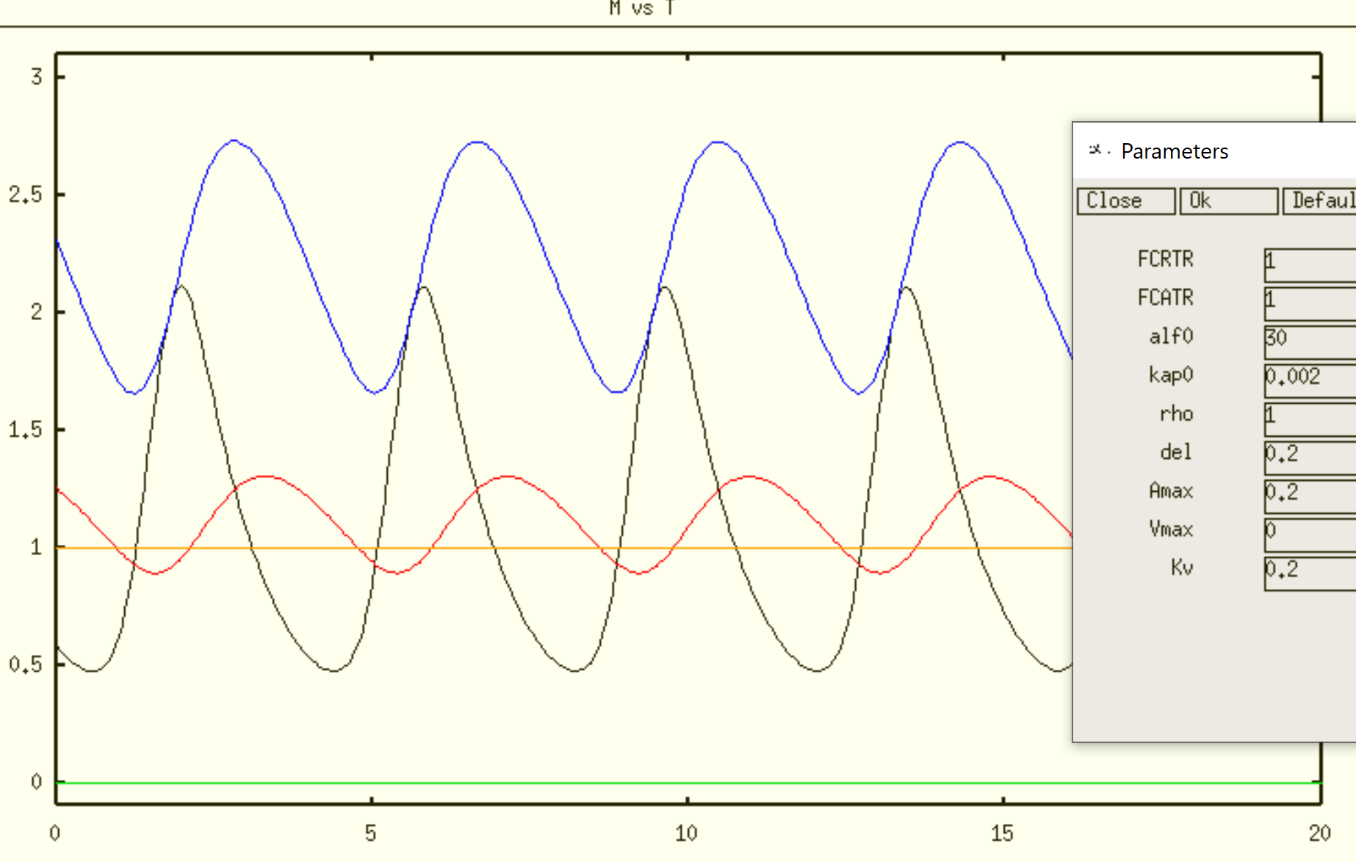

Key: mRNA (M) = black

PERtot (Ptot) = blue

PERnuc (P) = red

BMAL (AT) = orange

REV-ERB (V) = green

Next, add V(t) and AT(t). Choose Vmax=5; and Amax=0.39 so that <AT(t)> = 1.

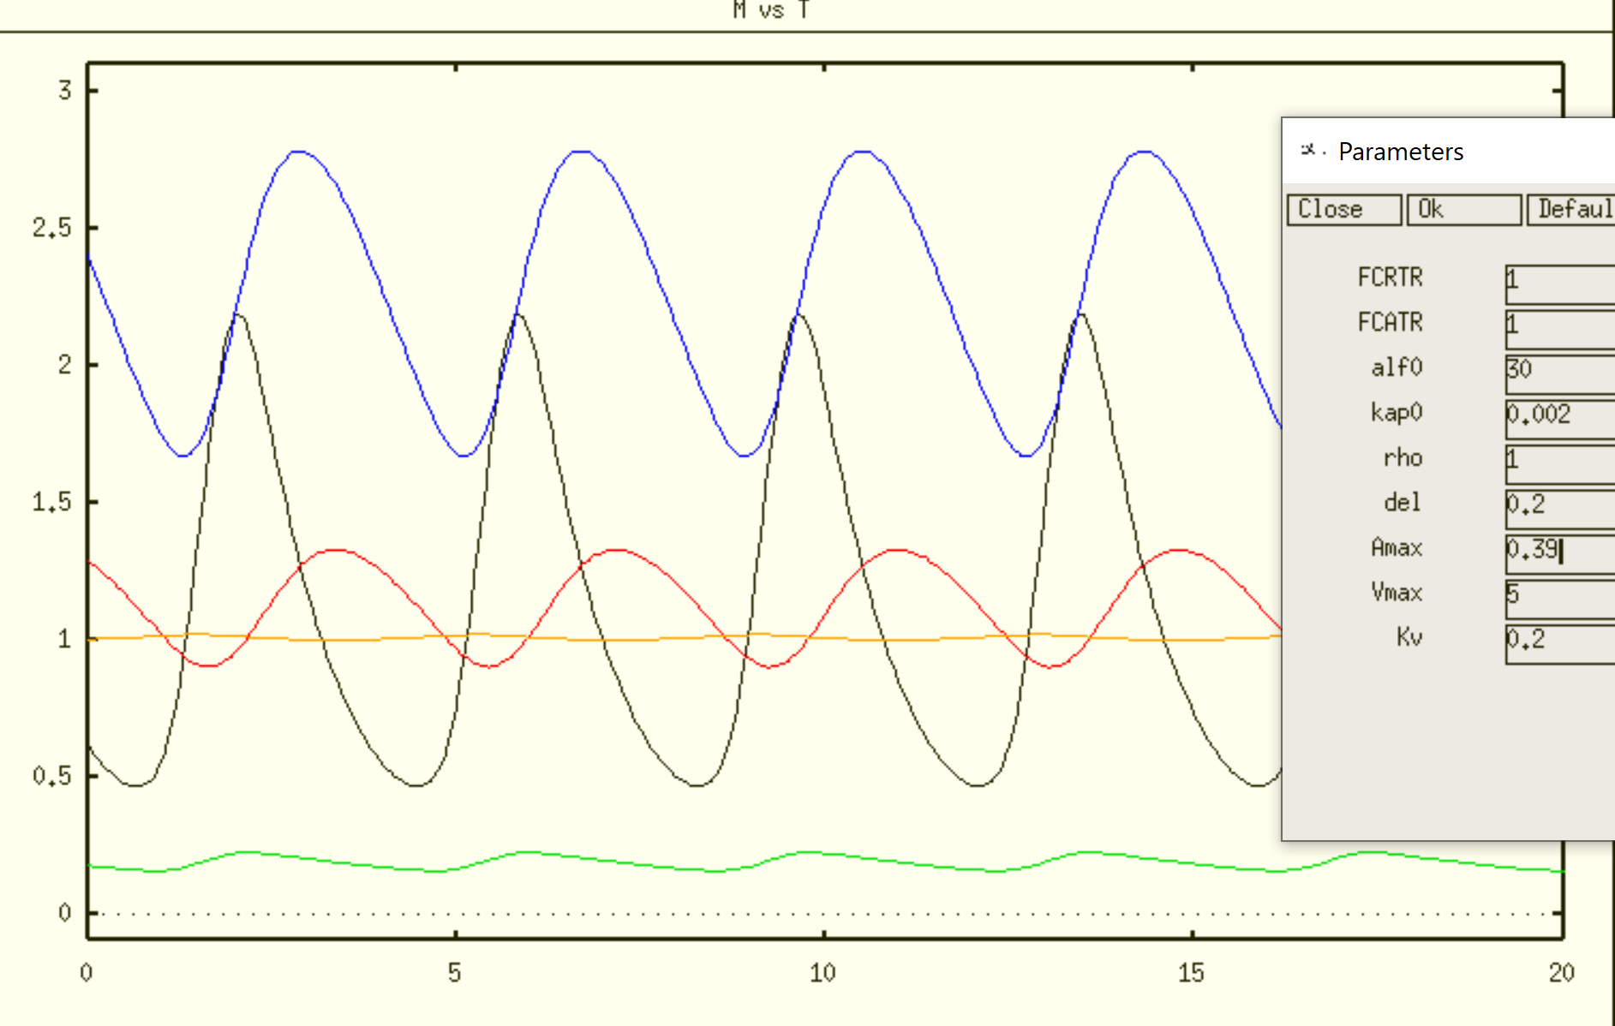

|  |  |
| --- | --- |
|  |  |
|  |  |

HB at FCRTR = 0.2296, 6.084

As FCRTR increases, V decreases and AT increases to keep up with increasing PER in nucleus.

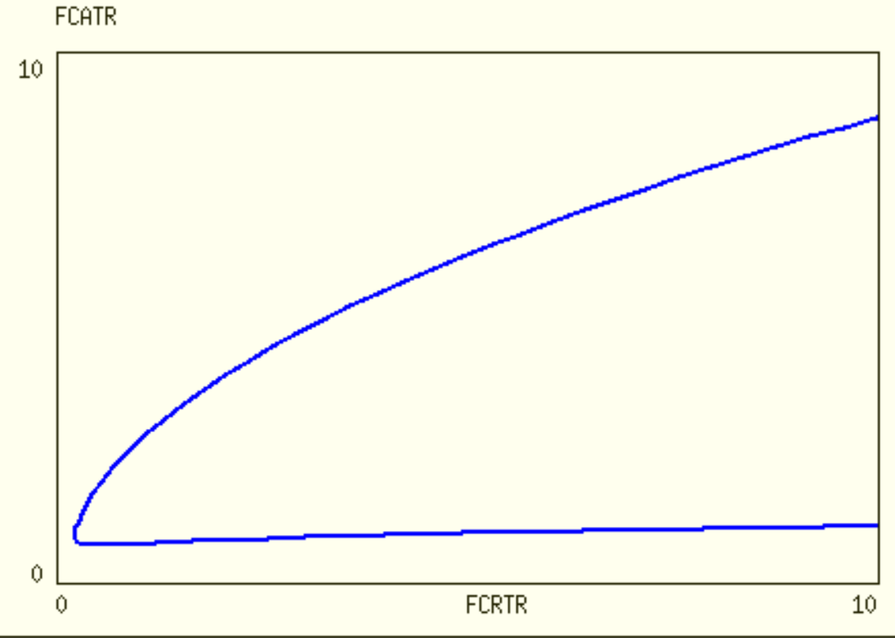

Notice that NNF is less robust than SNF with respect to FCATR. This seems counter-intuitive.

**# PNF(0L3) model SCALED**

alf = FCRTR*alf0/FCATR

kap = kap0*rho/FCATR

#E-box Rate Law 0

RL0 = 0.5*(1-(P/AT)-(kap/AT)+sqrt((1-(P/AT)-(kap/AT))^2+4*kap/AT))

dm/dt = alf*RL0 - m

dptot/dt = m - p

dp/dt = ptot - 2*p

dAT/dt = del*(FCATR*Amax*(eps + (Kr*R)/(Kr+R)) - AT)

dR/dt = del*(Rmax*RL0 - R)

aux q=ptot-p

par FCRTR=1, FCATR=1

par alf0=30, kap0=0.002, rho=1

par del=0.2, Amax=2.8, Rmax=5, Kr=100, eps=.2

@ Yplot=m, Ylo=0, Yhi=4

Done

First, reproduce SNF(0L3) with R(t)=0 (green) and AT(t)=1 (orange)

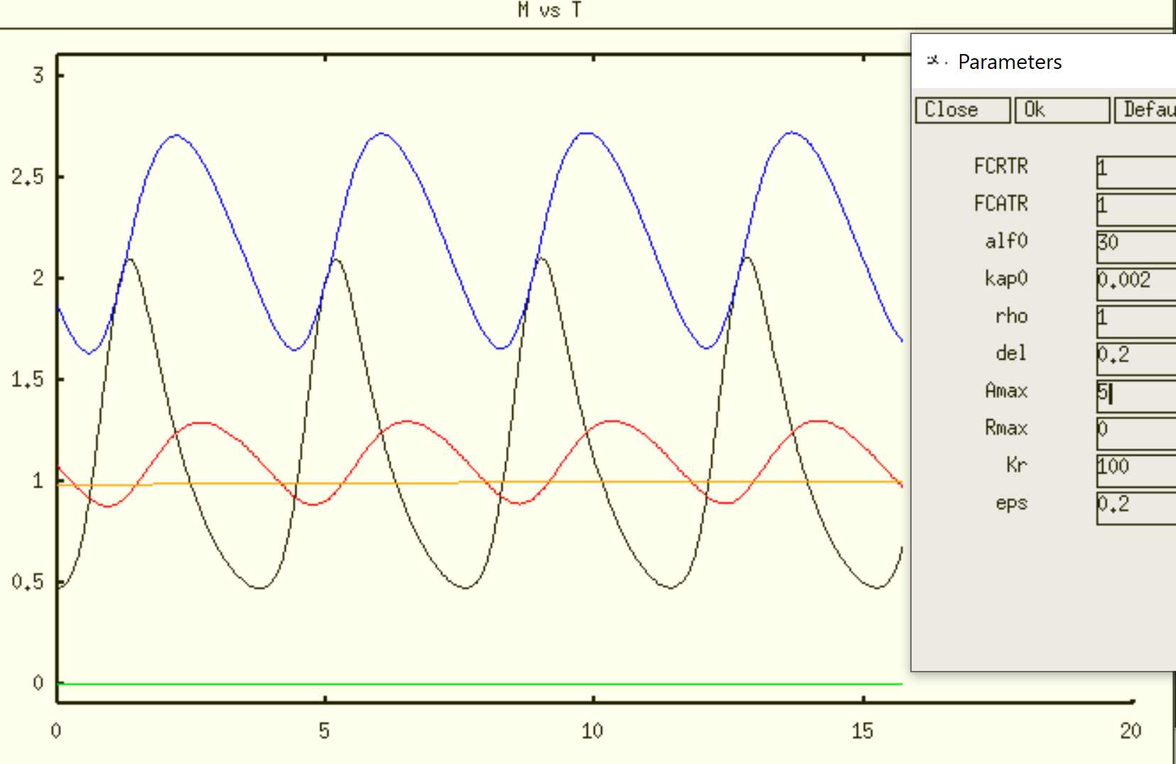

Next, add R(t) and AT(t). Choose Rmax=5; and Amax=2.6 so that <AT(t)> = 1.

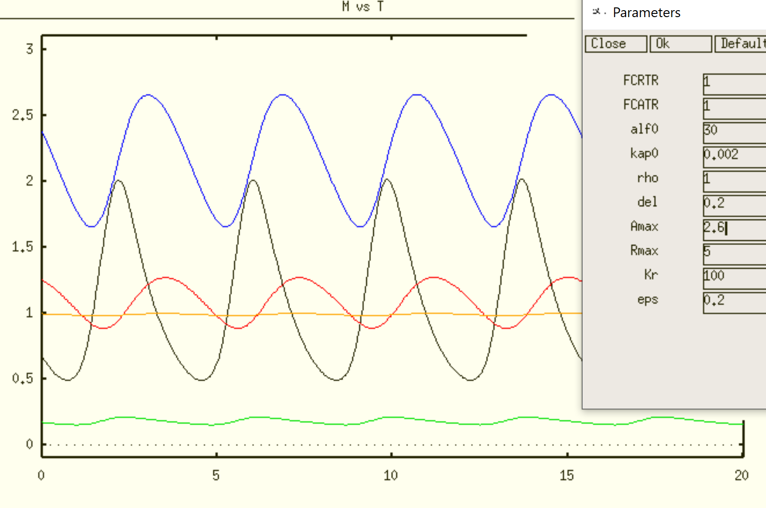

HB @ FCRTR = 0.5557, 1.314

|  |  |
| --- | --- |
|  |  |
|  |  |

This is also a counter-intuitive result. As FCRTR increases, PERnuc decreases…because AT decreases…because ROR decreases. The PNF bifurcation diagram is least robust.

|  |
| --- |
|  |
| Rough comparison: SNF (black), NNF (blue), PNF (red) |
|  |